|  |  |  |  |
| --- | --- | --- | --- |
|  | | | |
| AIUB | **American International University- Bangladesh (AIUB)**  **Faculty of Engineering** | | |
| **Course Name:** | Data Communication | **Course Code:** | COE 3201 |
| **Semester:** | Fall 2023 | **Term:** | Mid |
| **Total Marks:** | 30 | **Submission Date:** | 02-11-2023 |
| **Faculty Name:** | Mr. Abrar Fahim Liaf | **Assignment:** | 01/OBE |

Course Outcome Mapping with Questions

|  |  |  |  |  |  |  |  |
| --- | --- | --- | --- | --- | --- | --- | --- |
| **Item** | **COs** | **POIs** | **K** | **P** | **A** | **Marks** | **Obtained Marks** |
| **Q1** | **CO3** | **P.c.3.C5** | **K5** | **P1, P2, P6** |  | **15** |  |
| **Q2** | **CO3** | **P.c.3.C5** | **K5** | **P1, P2, P6** |  | **15** |  |
| **Total:** | | | | | | **30** |  |

**Student Information:**

|  |  |  |  |
| --- | --- | --- | --- |
| **Student Name:** |  | **Student ID:** |  |
| **Section:** |  | **Department:** |  |

**Marking Rubrics (to be filled by Faculty):**

|  |  |  |  |  |  |  |  |
| --- | --- | --- | --- | --- | --- | --- | --- |
| **Problem** | **Excellent**  **[15]** | **Proficient**  **[12]** | **Good**  **[10]** | **Acceptable**  **[7]** | **Unacceptable**  **[5]** | **No Response**  **[0]** | **Secured Marks** |
| Detailed unique response explaining the concept properly and answer is correct with all works clearly shown. | Response with no apparent errors and the answer is correct, but explanation is not adequate/unique. | Response shows understanding of the problem, but the final answer may not be correct | Partial problem is solved; response indicates part of the problem was not understood clearly. | Unable to clarify the understanding of the problem and method of the problem solving was not correct | No Response/(Copied/identical submissions will be graded as 0 for all parties concerned) |
| **1** |  |  |  |  |  |  |  |
| **2** |  |  |  |  |  |  |  |
| **Comment** |  | | | | | Total marks (30) |  |

**1.** ***Assess*** the effect of communication networks on environment and obtain the 8-bit data stream for each case depicted in Figure 1.

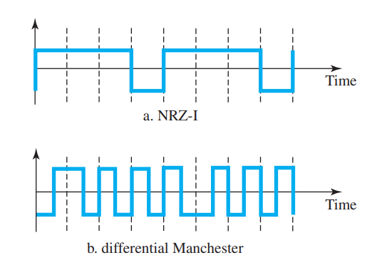

**Figure 1:** Graph for problem 1.

**2. *Evaluate*** the data streams **00110011** and **01010101** by graphically representing them using thefollowing schemes below. Assume that the last signal level has been positive.

* **NRZ-L**
* **Manchester.**
* **2B1Q**